Link to the project GitHub repository: https://github.com/occloduhight/autodisproject
The goal of the project is to deploy a highly available, scalable and secure java-based pet adoption application using jenkins pipeline that ensures the that EC2 instances spin up by Autoscaling Group will have updated codes automatically.
Tech Stack Used
Several DevOps, cloud, containerisation, and monitoring tools.
- AWS – Cloud platform used for hosting infrastructure and application services.
- GitHub – Used for source code version control and team collaboration.
- Terraform – Infrastructure as Code (IaC) tool used to automate infrastructure provisioning and management.
- Ansible – for configuration management
- Jenkins - responsible for provisioning the infrastructure that will go live using the jenkins pipeline
- Nexus repository: for management of artifacts and help in managing docker image.
- Vault - to store database credentials
- Sonarqube - for static code analysis
- Docker - Docker allows the application to run consistently across environments by packaging the application with all dependencies into containers.
- OWASP Dependency-Check – Scans libraries for vulnerabilities.
- Trivy – Container vulnerability scanning.
- OWASP ZAP – Dynamic security testing.
- Checkov – Infrastructure security scanning.
- New Relic – Application monitoring
- Slack – Pipeline notifications

Infrastructure Creation Process
The infrastructure was created in three major stages.
Stage 1: Initial Infrastructure Setup Using VS Code
The first stage involved provisioning the foundational resources using Terraform from VS Code. These resources included the S3 bucket, which stores the Terraform state files; the Utility VPC, which hosts the public subnet, internet gateway, and security groups; and the Jenkins and Vault servers, which provide the CI/CD automation environment and secure secrets management.
To provision the initial infrastructure, the process begins by spinning up the S3 bucket and then creating the Vault and Jenkins server infrastructure by running the script ./create-s3-bucket.sh. This script automatically creates the S3 bucket and prepares the backend required for Terraform state management before the rest of the infrastructure is deployed.

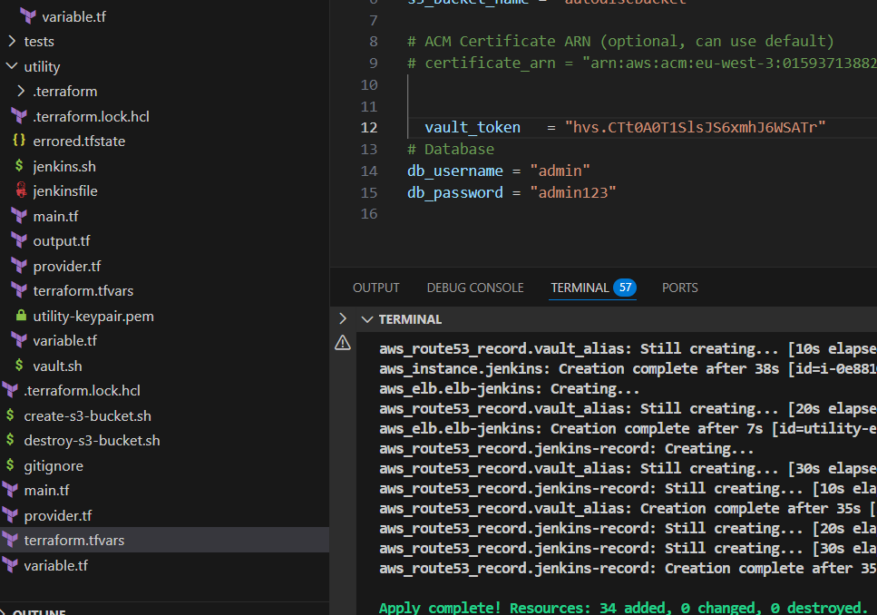

Stage 2: Infrastructure Pipeline via Jenkins
After Jenkins and Vault were successfully deployed, the Infrastructure Pipeline was created from the Jenkins dashboard to automate the provisioning of the main application infrastructure. This pipeline handles the automated creation and configuration of the required servers and supporting resources needed for the application environment. After the provisioning process was completed, the servers were given a few minutes to fully configure, after which Jenkins was accessed and connected through AWS Systems Manager (SSM) to manage and verify the deployed infrastructure.
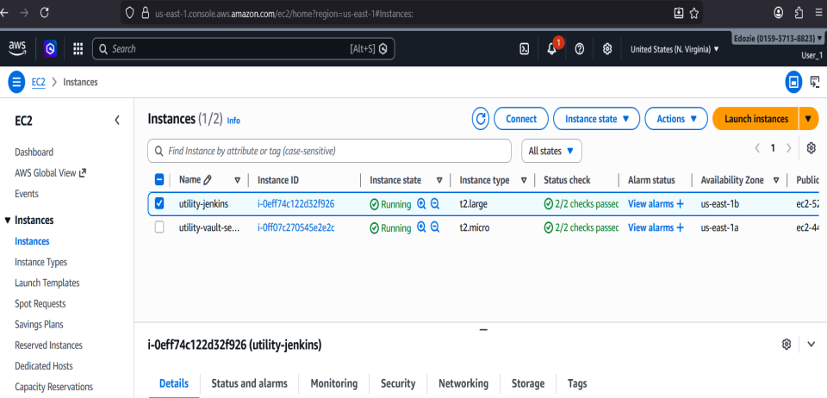

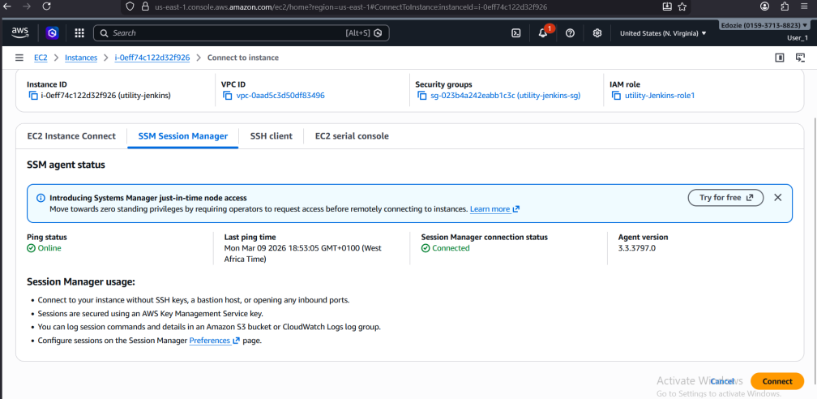

Connect to the jenkins-server via the browser. To do this use: jenkins-your domain name

Copy the initial administrator part from jenkins browser, go to the jenkins ssm dashboard and run sudo cat (paste the part copied), press enter
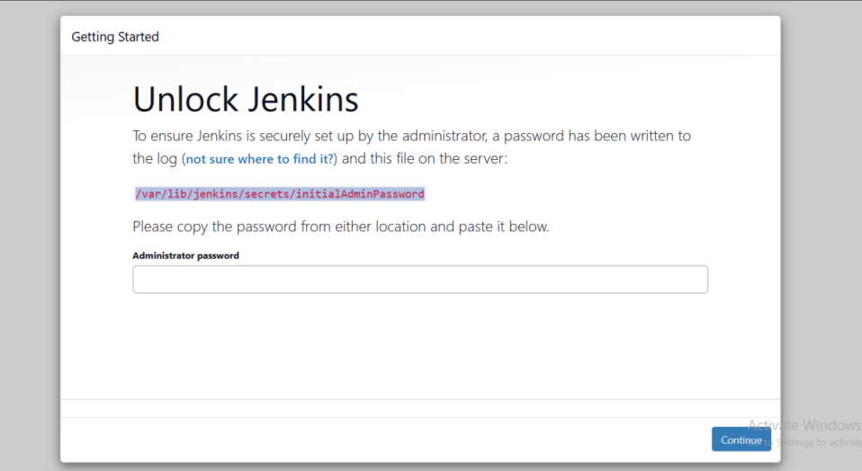
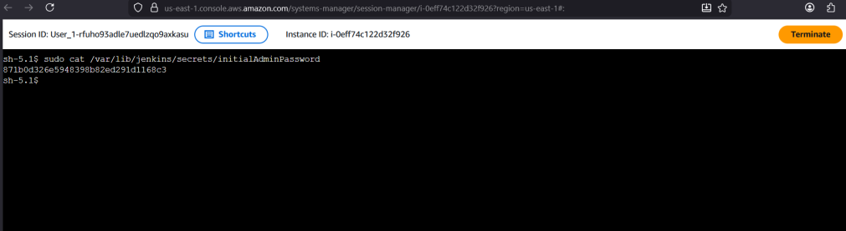

Next, copy the token generated, then go back to jenkins browser and paste it at the Administrator password

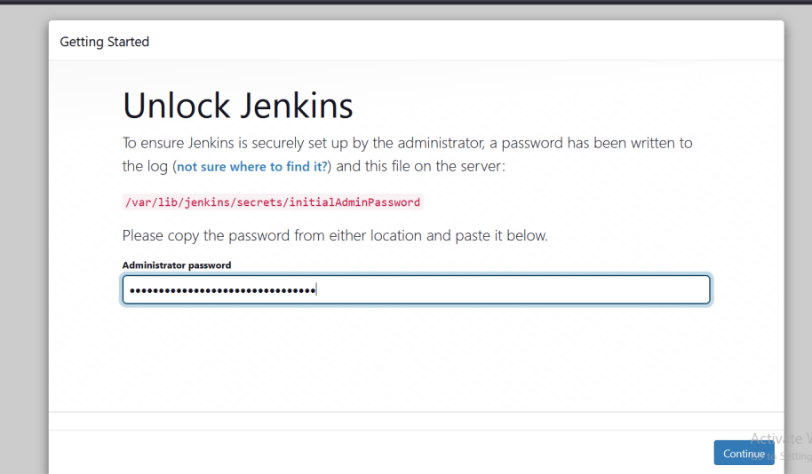

Select continue, click on suggested plugins to install some default plugins

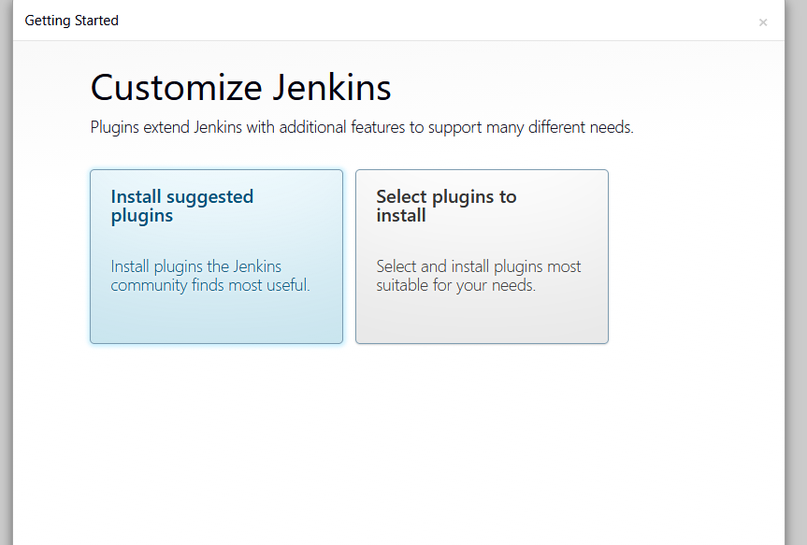

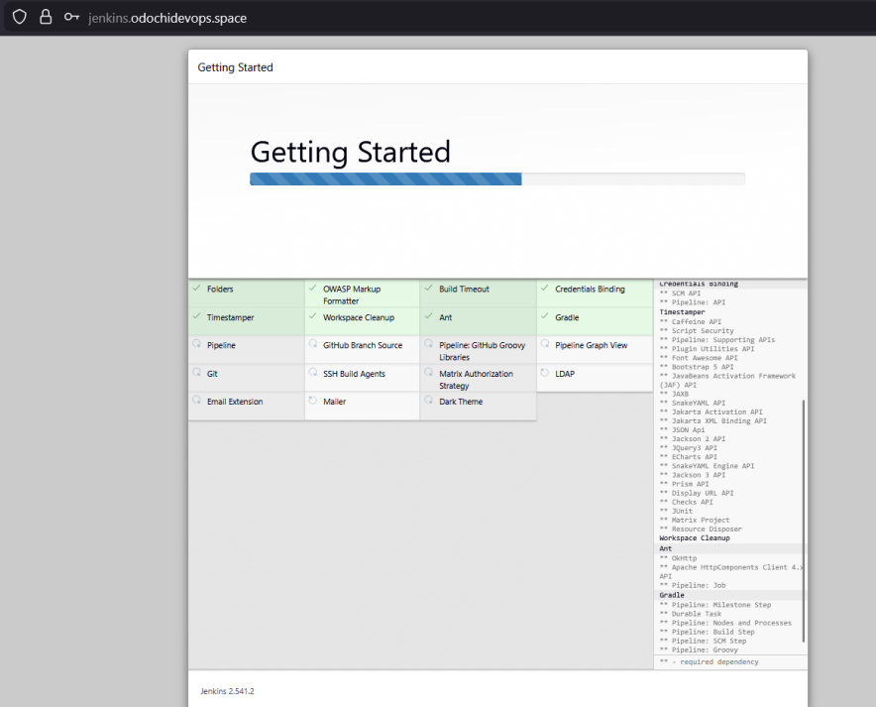
Give it a name and fill in other fields, then select save and continue

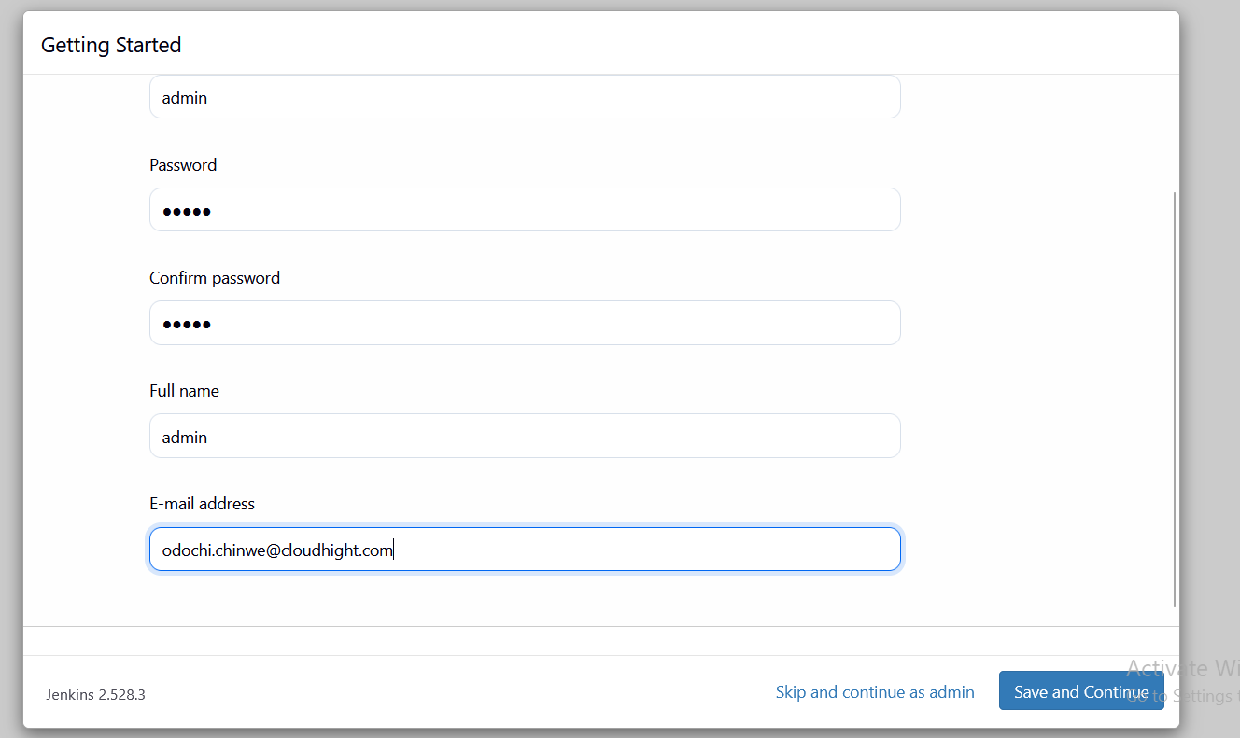

Select Save and Finish, then start using jenkins

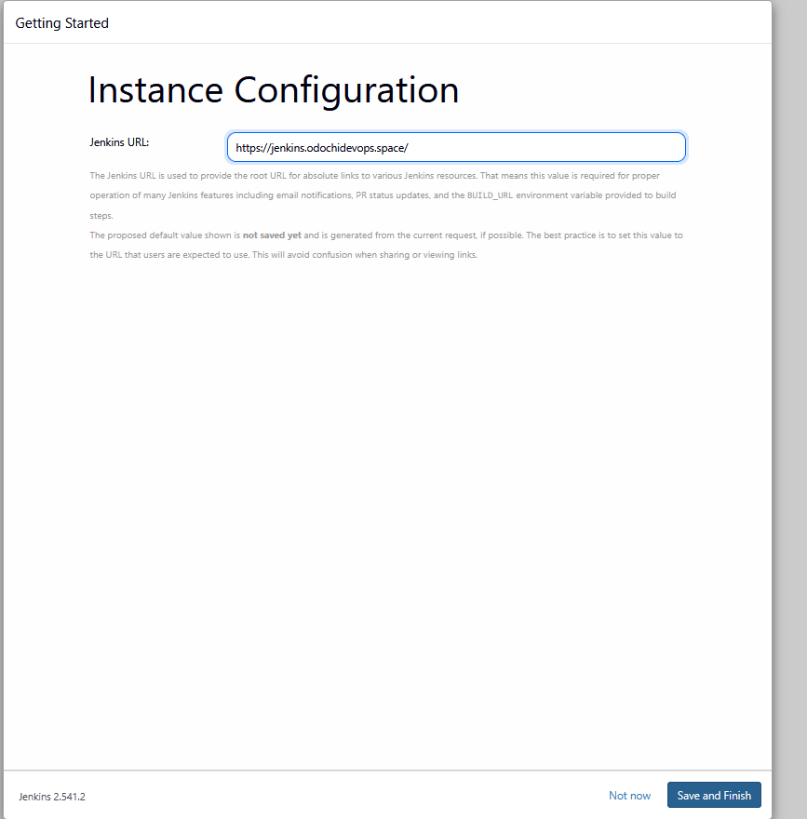

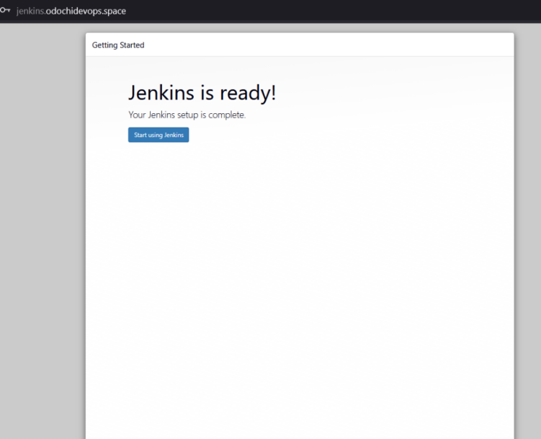

In the jenkins server the first thing to do is to install plugins. To do this, click manage jenkins

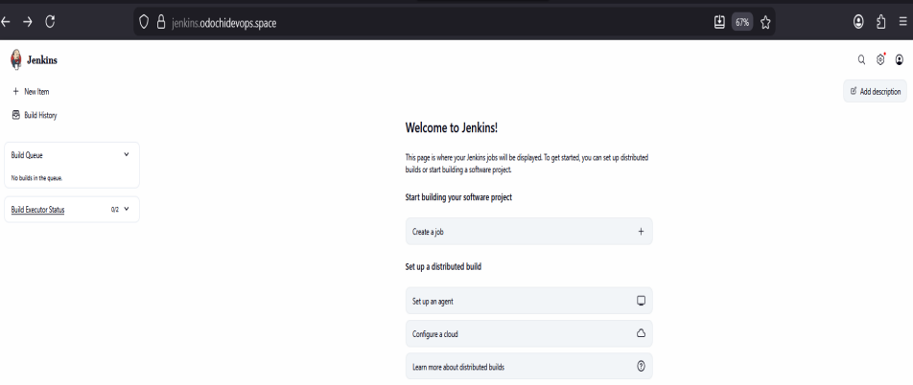

Next is to install terraform and ASW plugins. To do this, select plugins

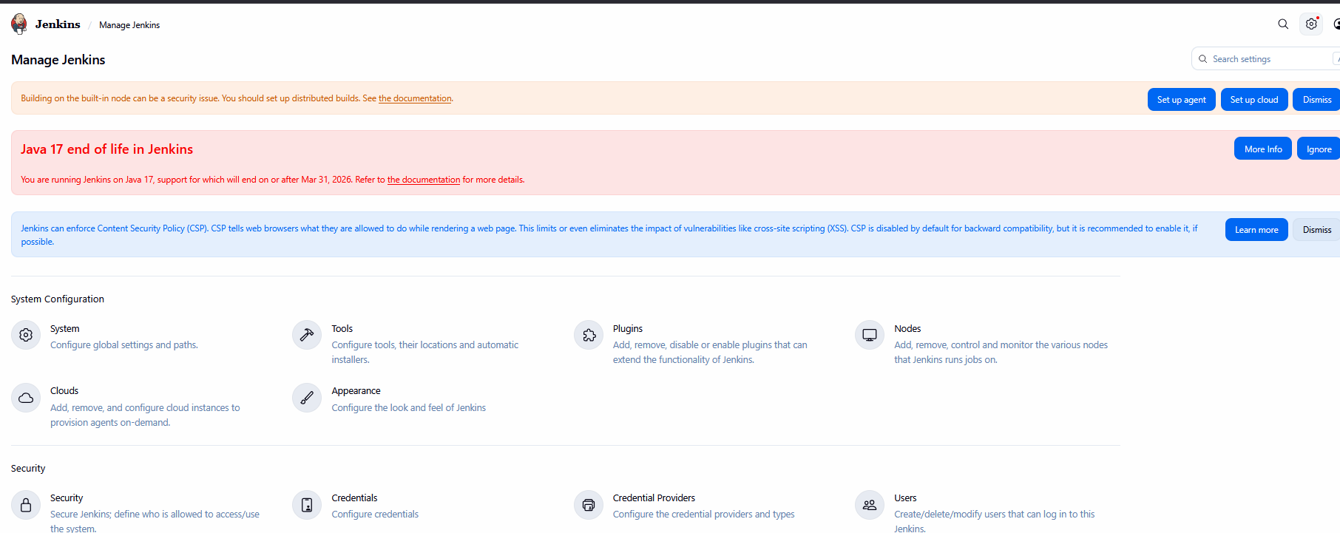

Next is to select installed plugins

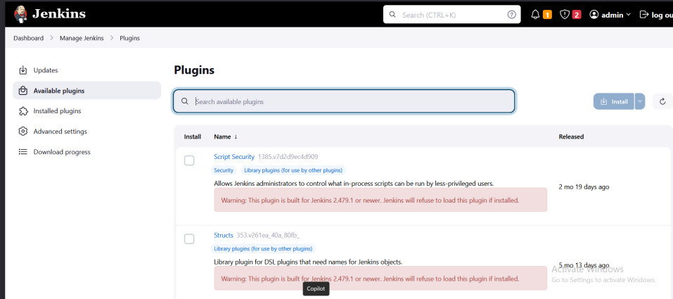

To install the plugins for infrastructure pipeline configuration, Search for the following: terraform, aws credentials, pipeline stage view, html publisher, and slack. Then click install

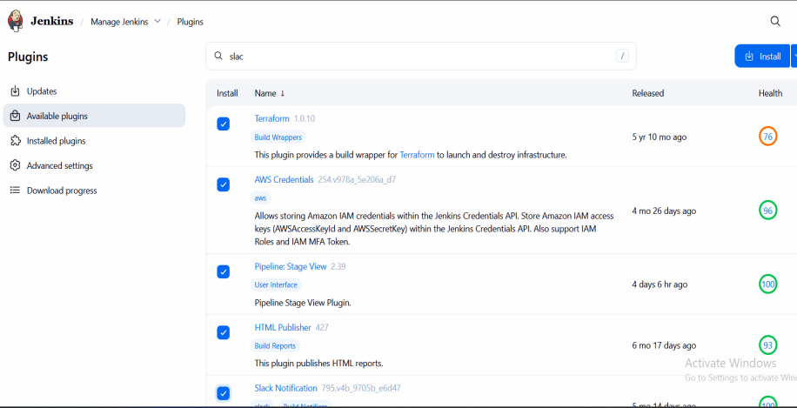

Be sure all plugins are successfully installed

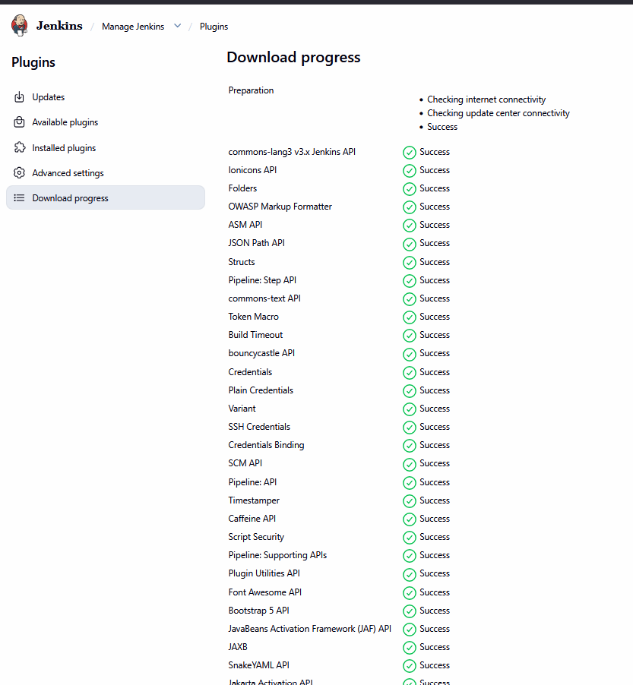

To Automate the configuration for terraform, go back to manage jenkins; select tools
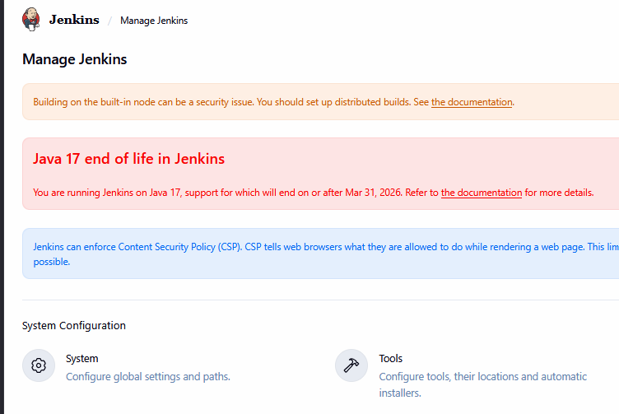

Next, scroll down to terraform installations. To install the plugins for terraform; select Add terraform. Give it a name that matches the one on the jenkinsfile. For this project, give it terraform, scroll down to terraform installation: select install automatically, then choose the version that suits the server. Here linux server is used hence terraform 1.14.6 linux (amd64) selected from the drop down list. Note: there are other latest versions. Then click on save to automate the configuration for terraform plugin installation.

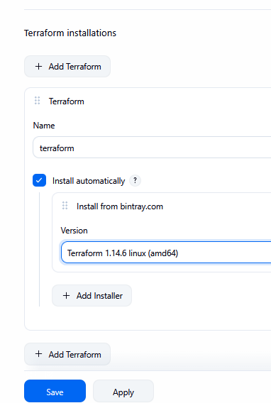

To configure slack, go back to manage Jenkins, select systems, then scroll down to slack…, at credentials, select Add , then global. Select secret text, then next. Fill in the field: Secret: Paste the Slack Bot Token, ID: slack, Click create.

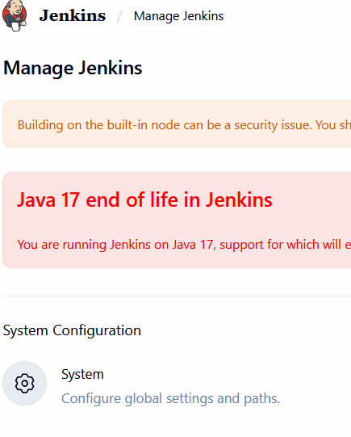
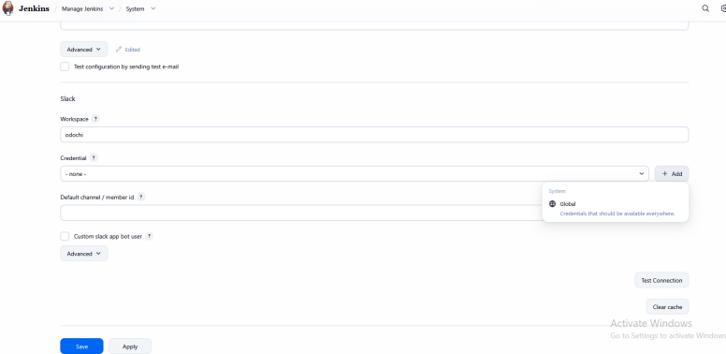
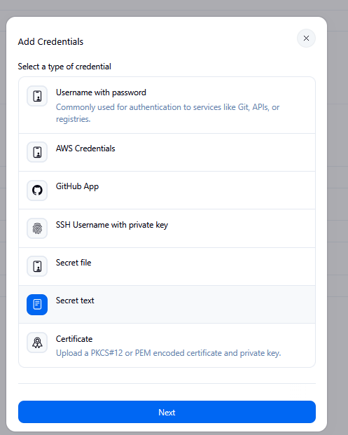

Input Slack token if already generated then create
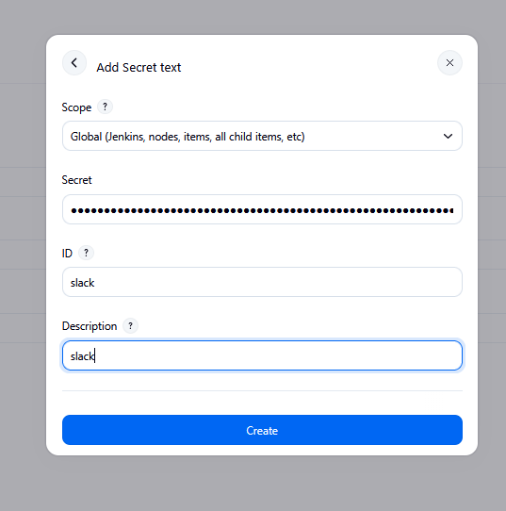

At the slack section, fill the fields like in as required:
- Workspace: odochi
- Credential: select slack
- Default channel / member id: COA94TNNGKC
- Check Custom slack app bot user
Test the Configuration. Click Test configuration by sending test e-mail / message. Confirm Jenkins sends a message to your Slack channel. If successful, you will see Success

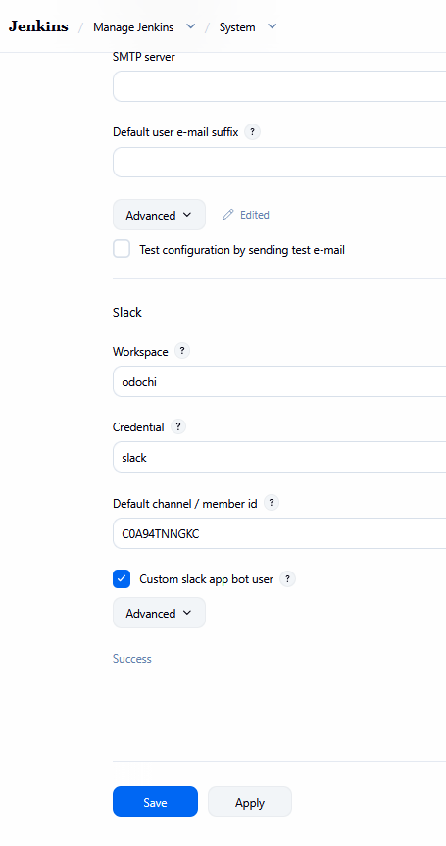

Then check in slack to confirm. Then, Save the Configuration. Click Apply. Click Save



Next is to Configure Credentials. This is needful here since the project GitHub repository is public and one is not expected to push secrets to the GitHub repository. To configure Jenkins credentials. Go back to manage jenkins, select credentials.

To add the following credentials: new relic key, new relic account id, database username, database password, and vault token. Go back to manage Jenkins, click on credentials. Select Global, then select Add Credentials

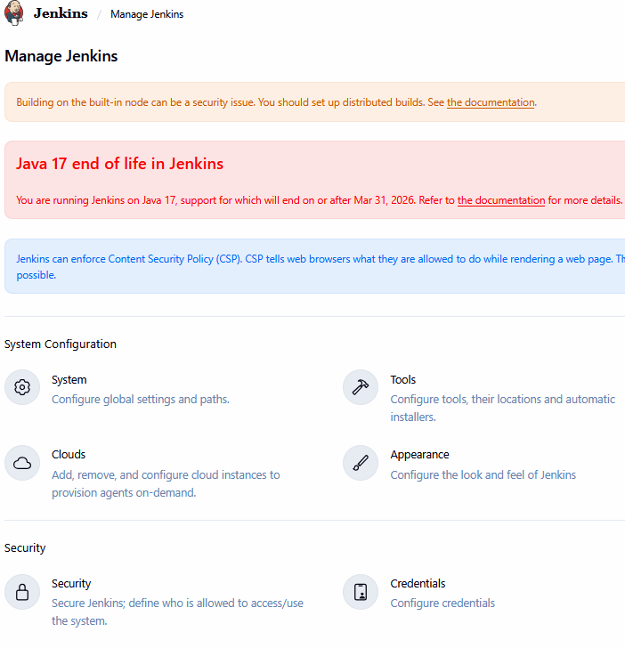

For Vault Token credentials, Go back to AWS Console EC2 Dashboard, select vault server, then connect
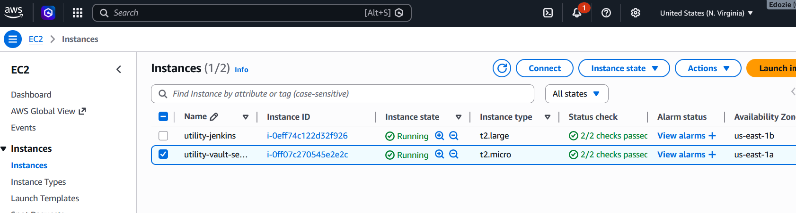

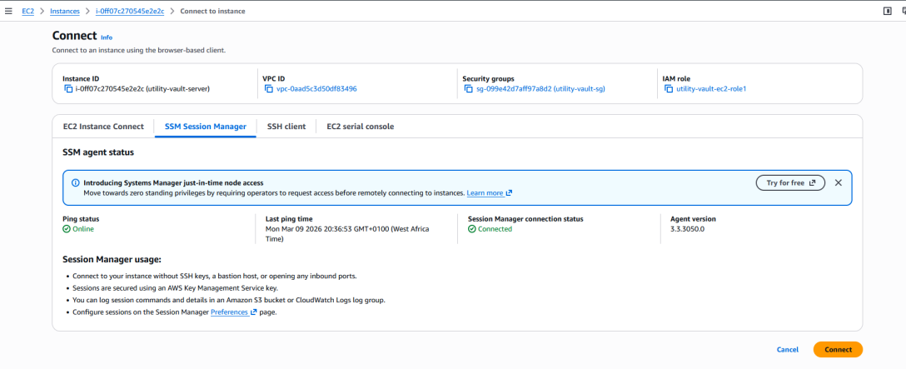

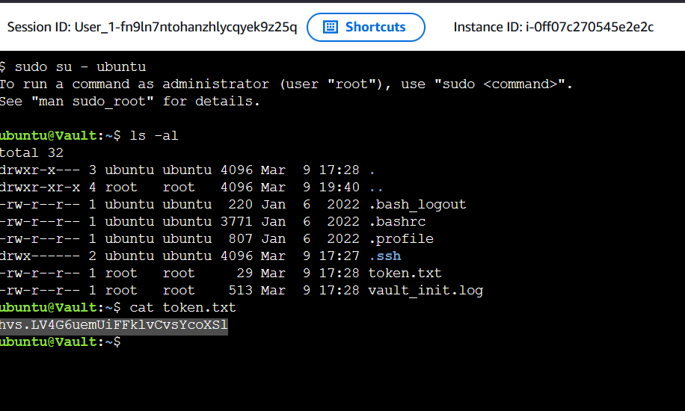

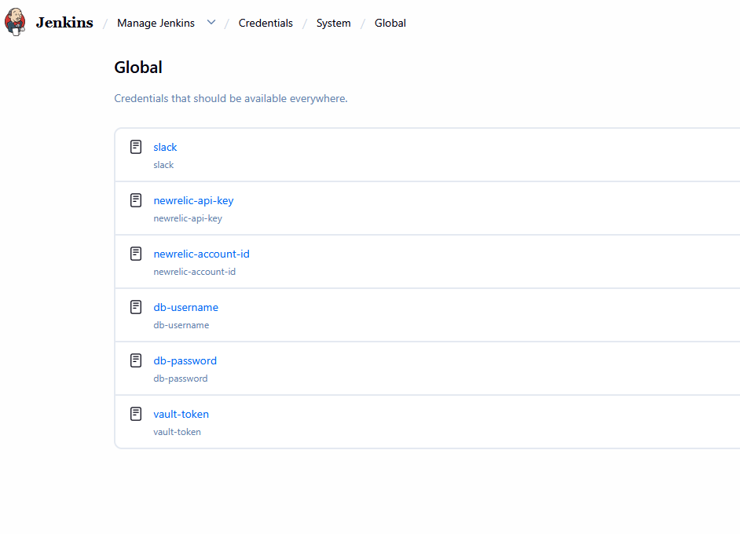

Next is to set up the pipeline. To do this, go to Jenkins dashboard, select New Item
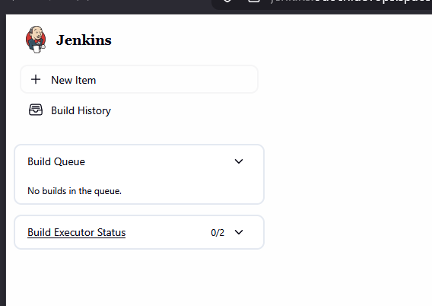

Give the pipeline a name (say infrastructure-pipeline, select pipeline then Ok
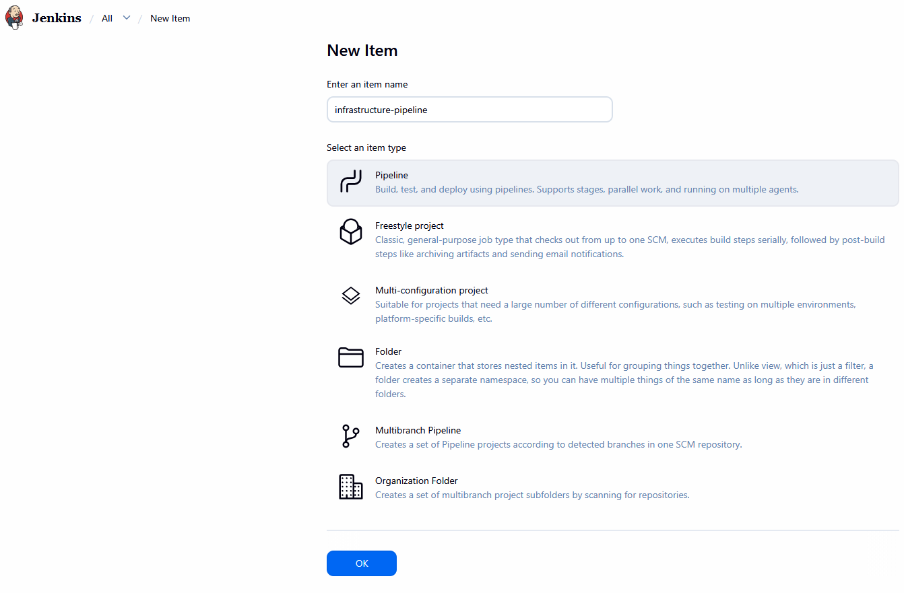

This will take you to jenkins user interface
Scroll down to pipeline, select pipeline script from SCM (for this project jenkins will not be stored on jenkins server rather it will be retrieved from Source Code Management tool; that is github repository). Under SCM select Git. Next is to copy the url of the repository to be integrated (this is copied from the git repo).
Note: if the git hub is private, you will need to configure the credentials using your github username and personal access token. This means that you will select Add jenkins; kind = username and password; username = your github username; password = personal access token; then give Id a name say git-credentials; then click Add.
But for this project the github repository is public hence, no credentials were added
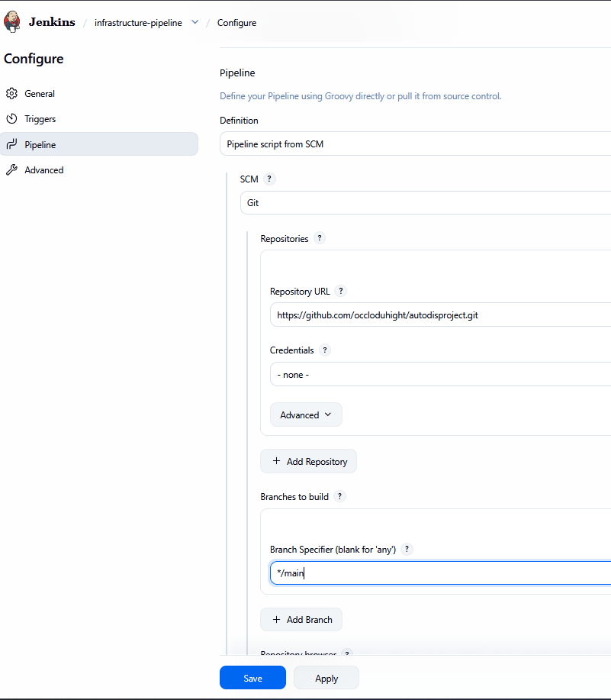

Now the jenkins pipeline is set to run
Next is to build, but because the parameter is codified in the jenkinfile the first build will be fail if you click at Build now . You will need to stop the build and rebuild to make it work. Click on Build now
Having stopped the build, next is to refresh the browser before rebuilding. You will now notice that the Build Now has changed to Build with Parameter showing that jenkins has recognized the jenkinsfile. Next is to click on Build with parameter

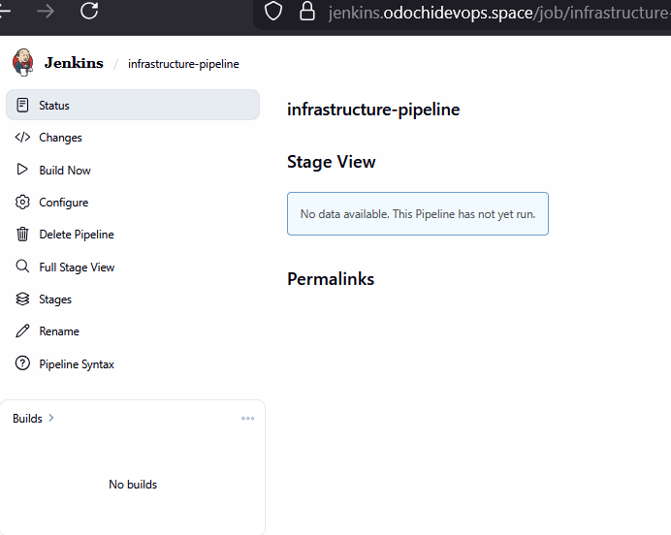

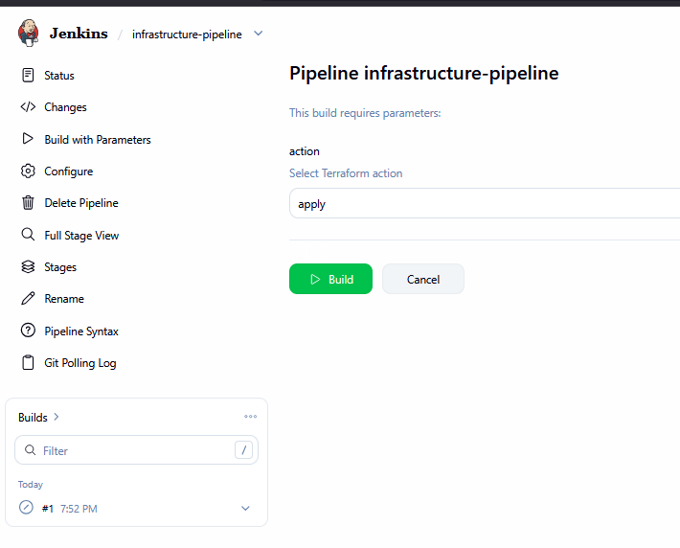

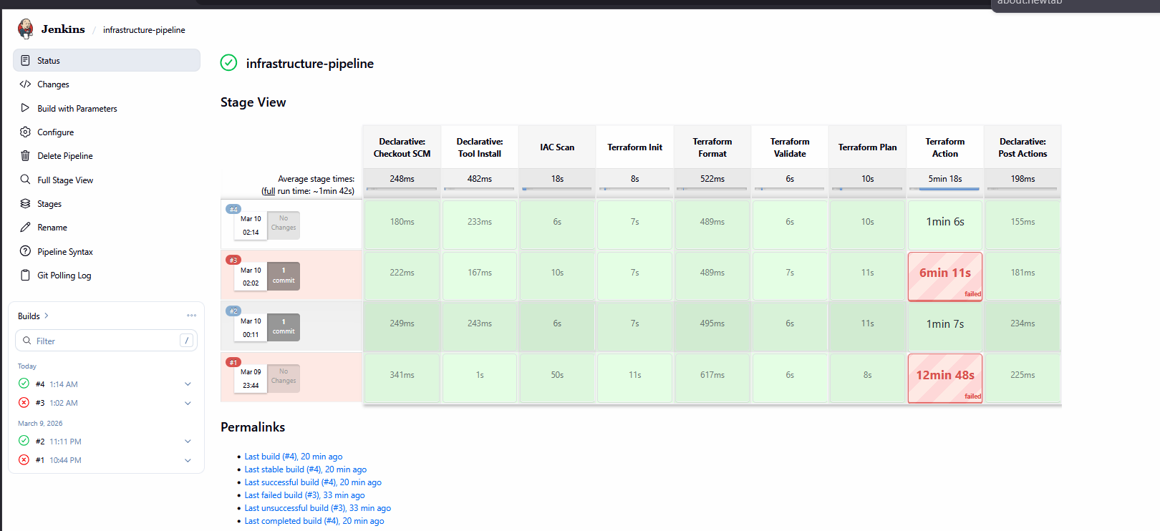
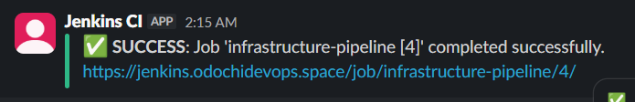

Next is to inspect the infrastructure to make sure that all the resources are provisioned, Go to AWS account to make sure that the services are there
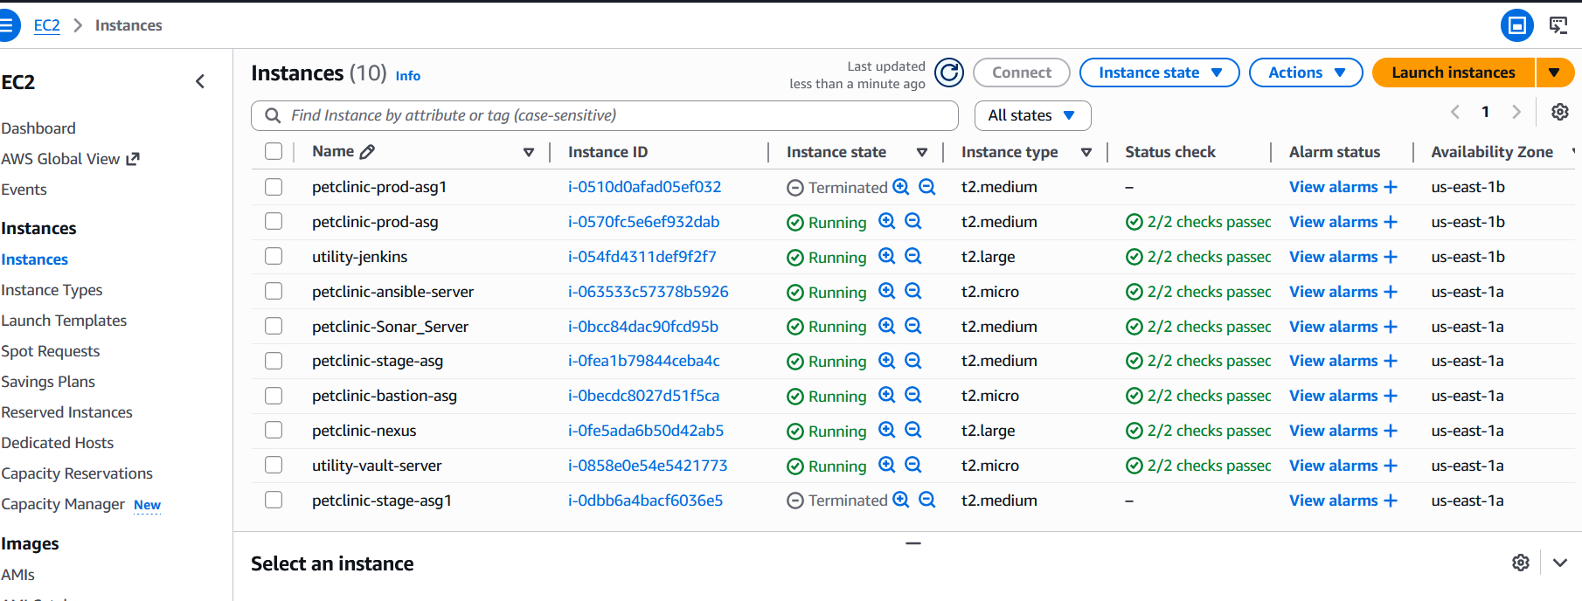

After successfully configuration of the infrastructure pipeline. Next is to check if the servers were created properly by going to the browser using the domain name
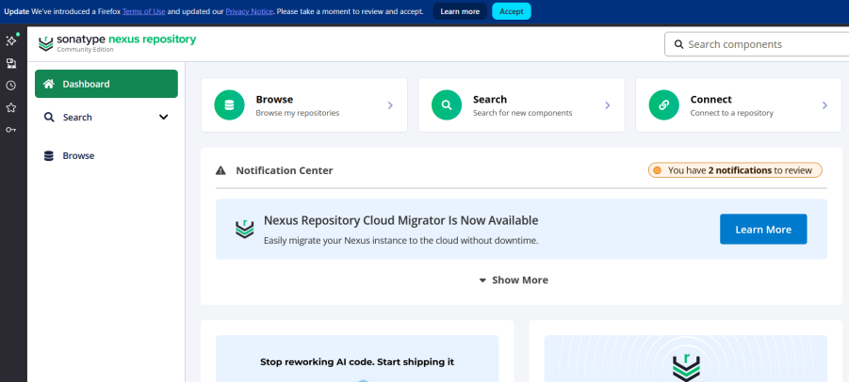

Stage 3: Application Pipeline
After infrastructure setup, the Application Pipeline was created to automate application build and deployment.
To set up the application pipeline: Go back to manage jenkins, Click on plugins, click available plugins. Then select the required plugins for the configuration of the application pipeline: Maven integration, nexus artifact uploader, Owasp Dependency Check, Sonarqube scanner, SSH agent, and Docker. Then click install

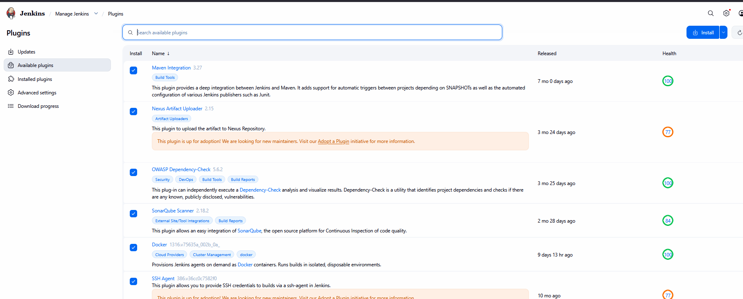

Next is to configure maven. To do this: Go back to jenkins ssm dashboard. Run: sudo su - ec2-user, then run: mvn --version
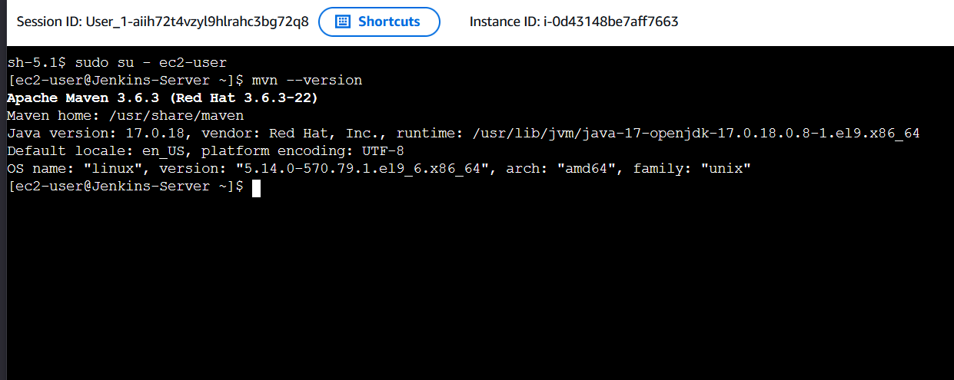

Next is to configure maven. To do this: go back to manage jenkins, select Tools. Under maven configuration, start with java by scrolling to JDK installations, select Add JDK. Give it a name

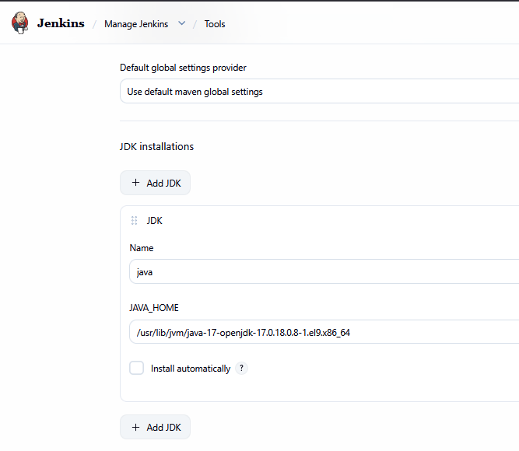
Scroll to Maven Installation, select Add maven, give it a name, deselect install automatically. Then paste the maven_home generated at jenkins ssm at the space provided.

Next, scroll down to Dependency-Check installations, under installation directory, select install automatically. Click Add Installer, at the drop down list select install from github.com, then click save.

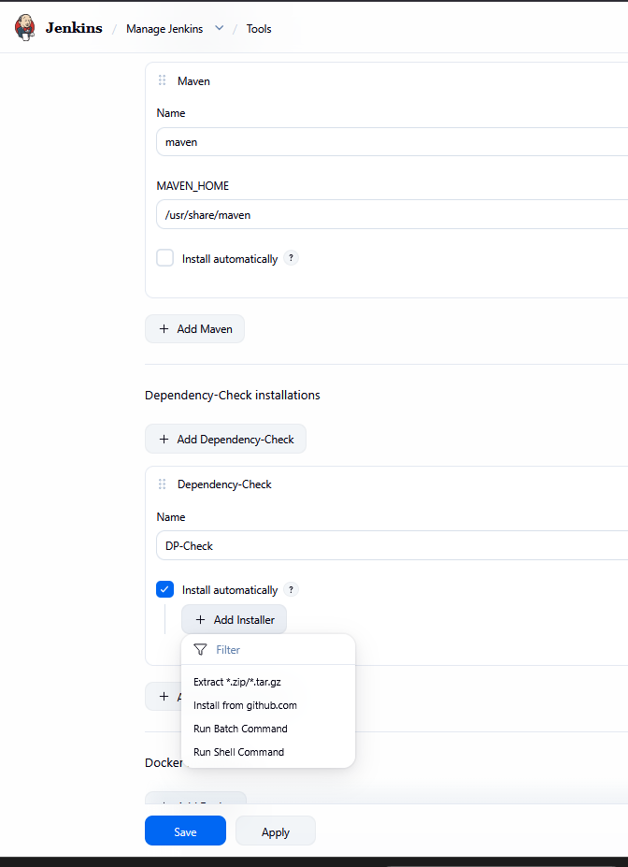

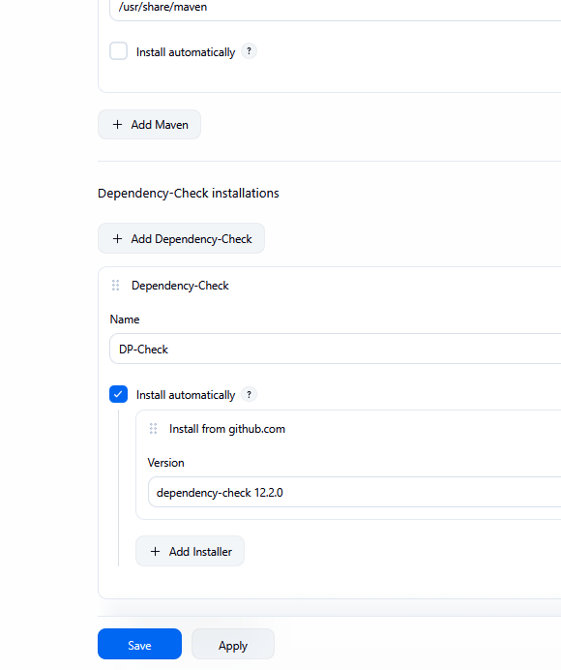
Next is to create the the following credentials for application pipeline configuration:
- git-creds (credentials for git): to give jenkins access to the github repo.
- sonarqube: to integratejenkins with sonarqube.
- nvd-key: To give access to OWASPs for it to download the database.
- nexus-maven-cred: to allow jenkins to push the artifact into the nexus-maven-repo.
- nexus-docker-username:
- nexus-docker-password
- nexus-docker-url
- bastion-id
- ansible-ip
- ansible-key
- bastion-key

To create nvd api key. To do this search for nvd api key request at the browser, the fill the form and click submit.
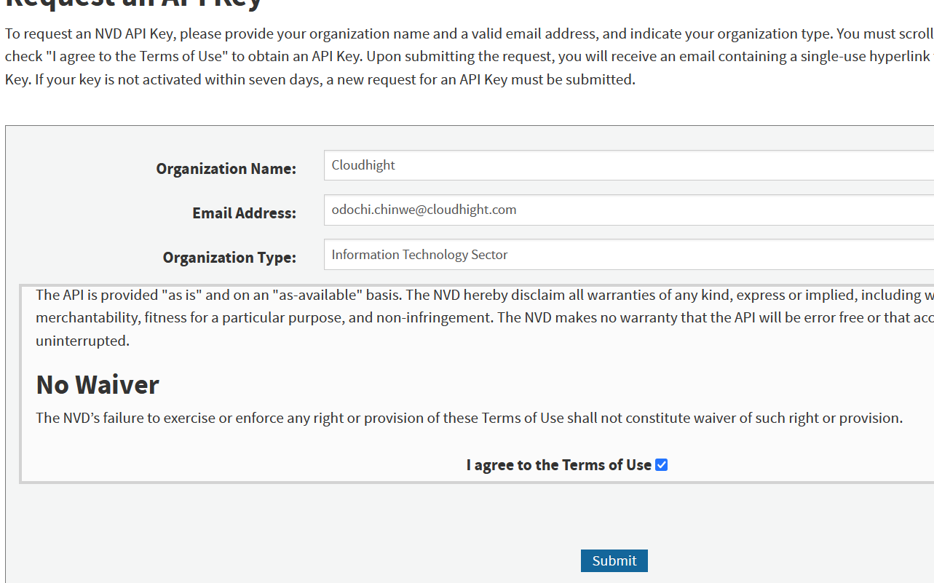

Next, go to the email, copy the uuid key, click the confirmation link above it. To validate the key. Complete the form as required, the click confirm.
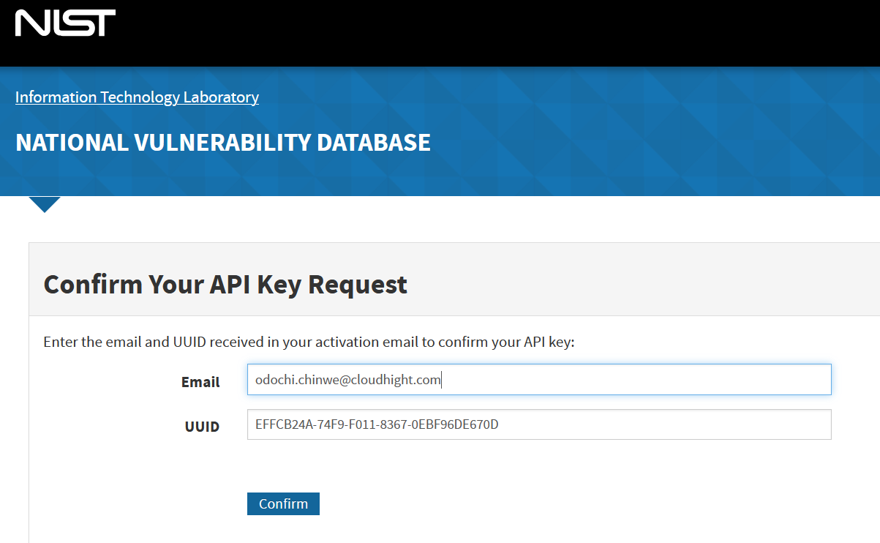

Copy the API Key. The go back to manage jenkins to configure the credentials. Select credentials and configure the required credentials. Click at global, the Add Credentials
Next, select Add Credentials to create credentials for git ( use your GitHub username and personal access token as password)
Next is to go to the GitHub where the jenkinfile to be used in building the application is located to reconfirm that it matches your project.
Next is to configure SonarQube, to do this login into SonarQube environment via the browser. Fill the form as required, the click login.

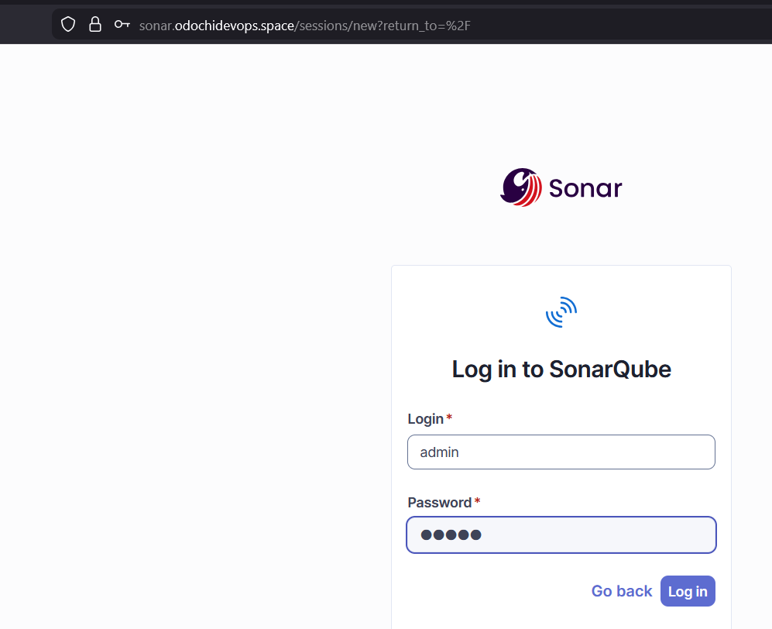

Update the fields as required
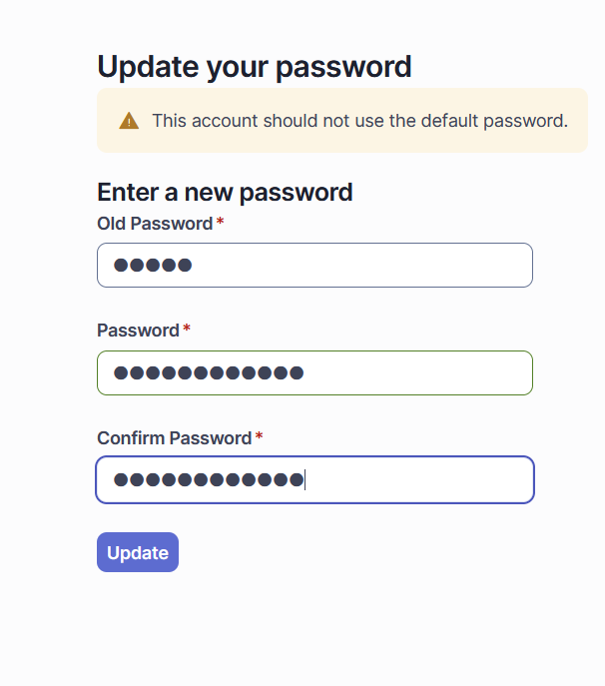
At SonaQube environment, select: Administration, then configuration. At the configuration drop down list select webhooks, then create

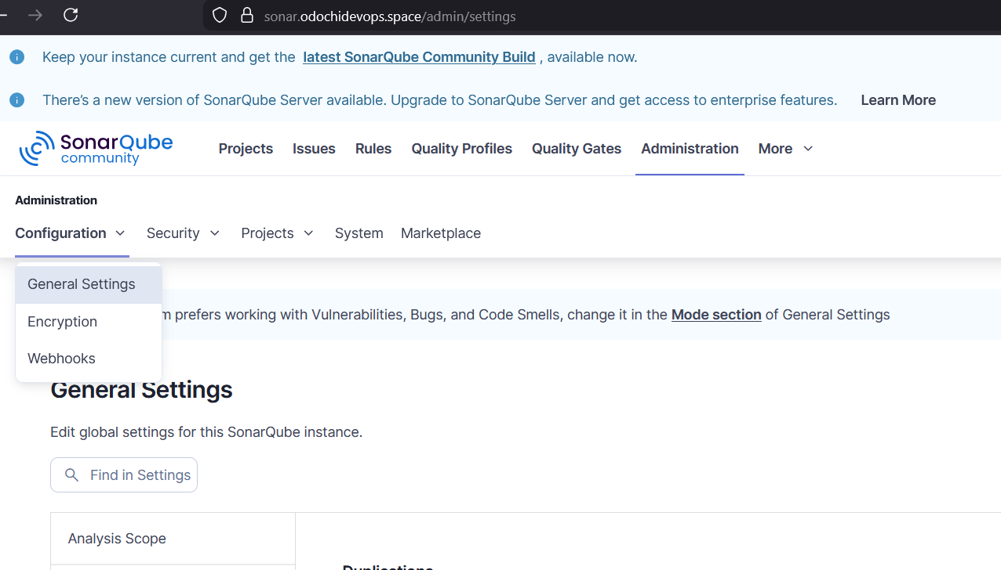

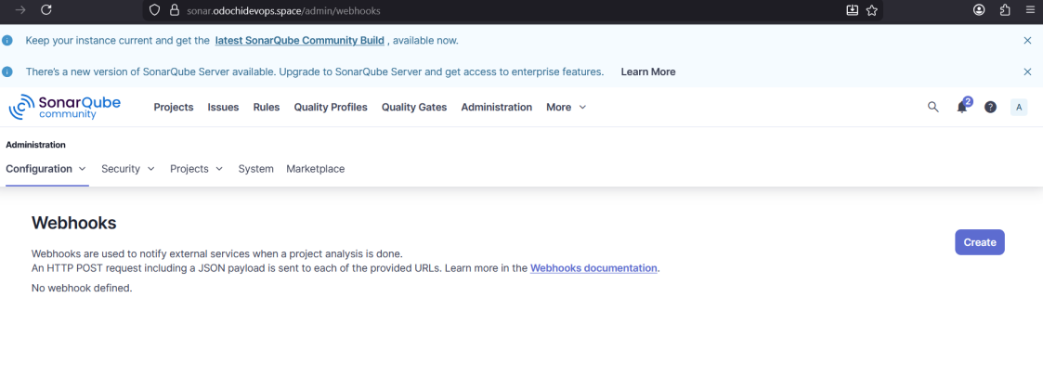

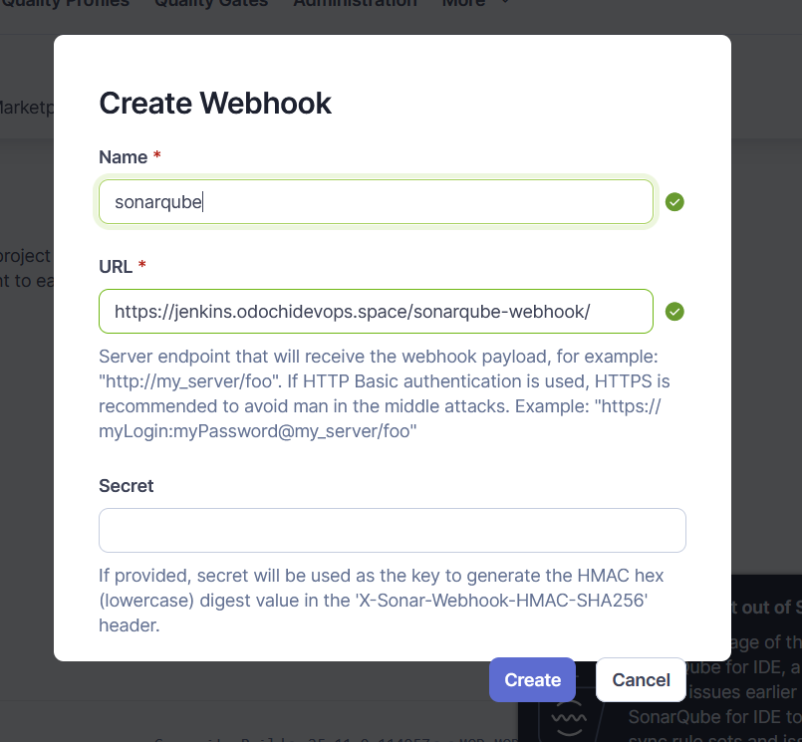

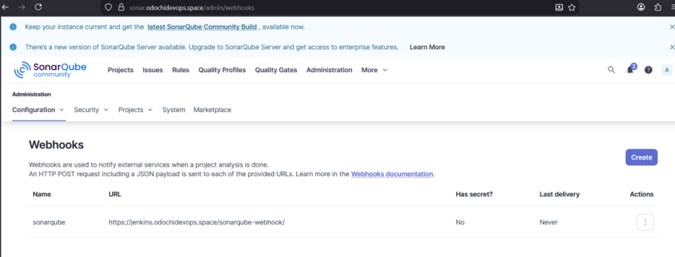
Next at the security drop down list, select users then token, then fill the required fields and click generate.

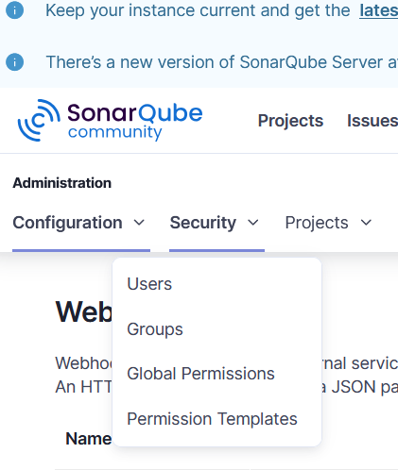

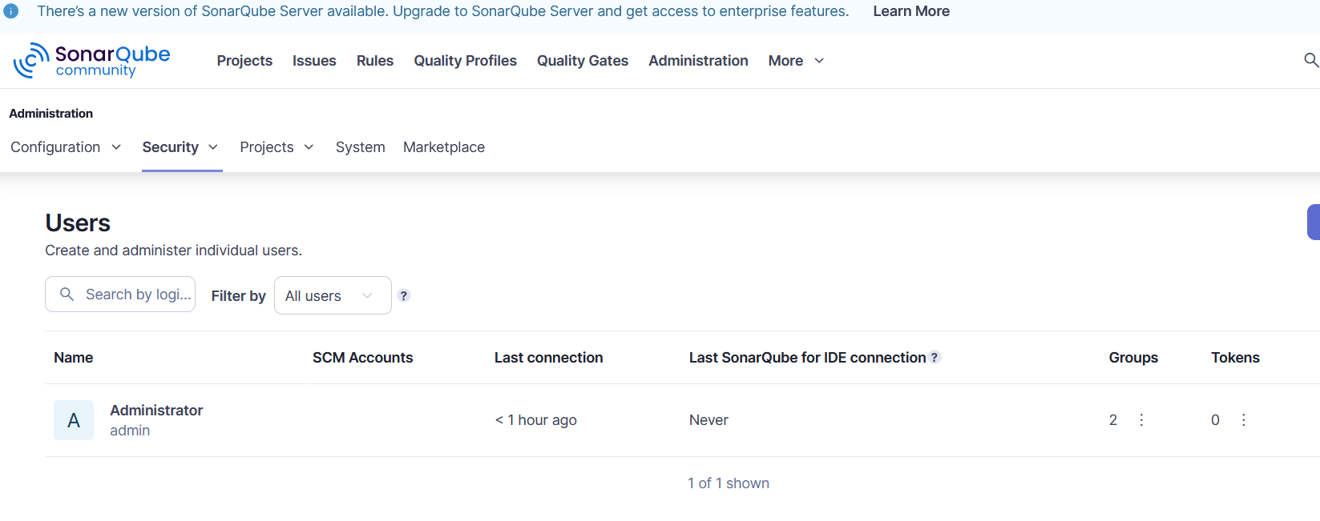

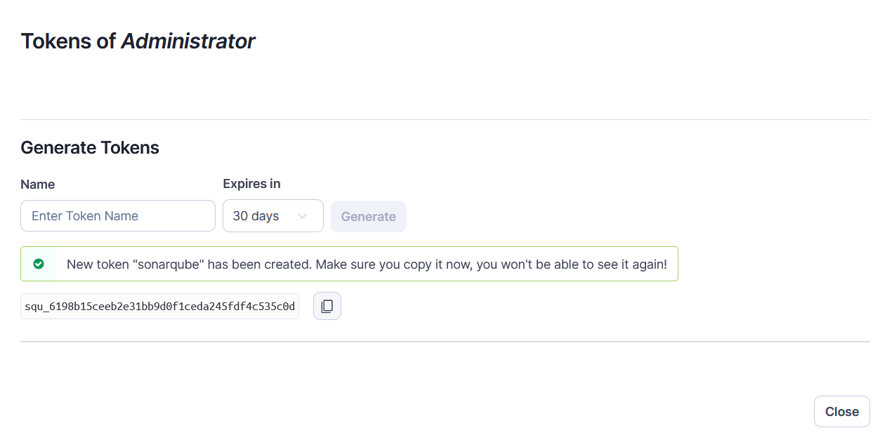
Next is to use the generated token to create credentials for sonarqube
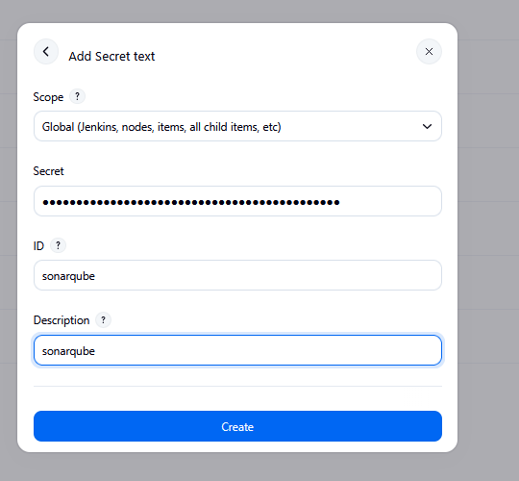

Next is to set up Sonarqube. To do this, at manage jenkins, select System. Scroll down to Sonarqube Servers, check Environment variable, click Add Sonarqube, then fill the required field under SonarQube installation. Fill the required fields, then save
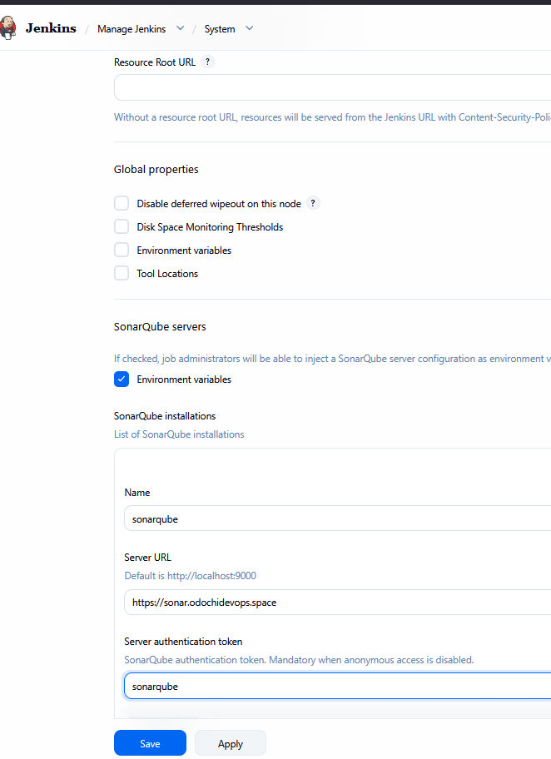

Note: To create the ansible-key and bastion-key, the keypair to be used is the one generated in the infrastructure-pipeline. To get the keypair, connect to jenkins via ssm, the run: cd /var/lib/jenkins/workspace/infrastructure-pipline
Next run: ls -al, then cat the key.pem (that is the key created by the jenkins pipeline. (this is the key to be pasted in enter directly box).

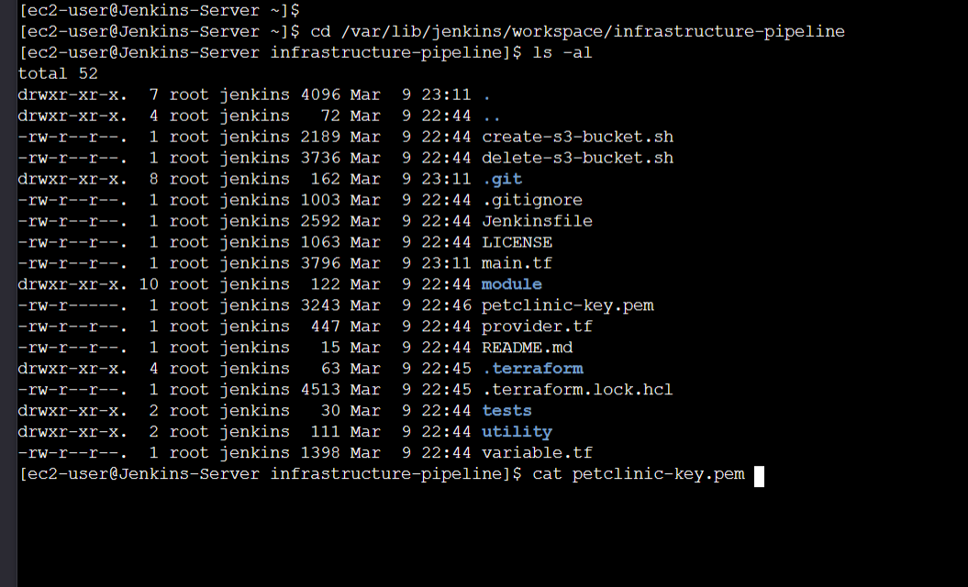
Next is to create the credentials for ansible-key and bastion-key
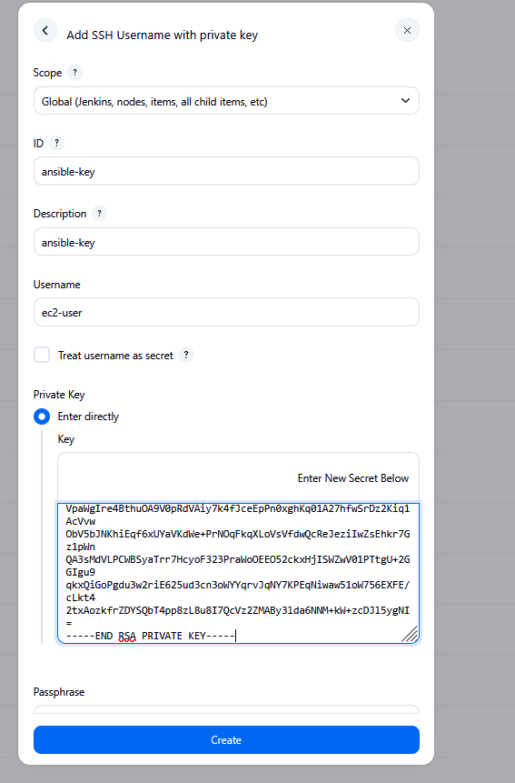

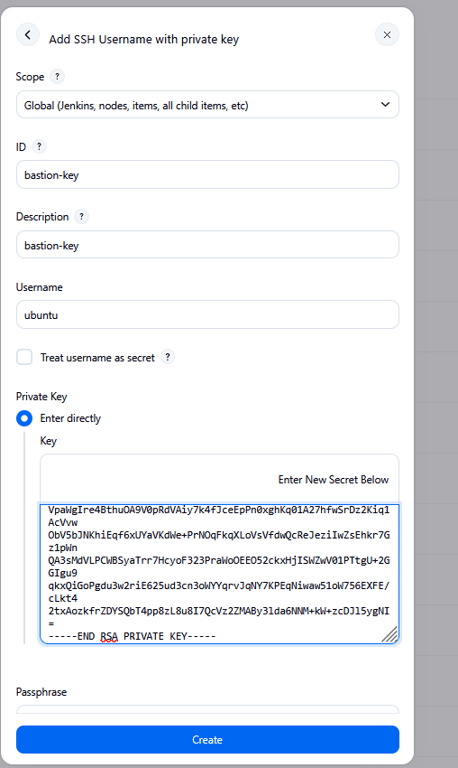

Next is to configure nexus. To do this go into the nexus server via the browser with the nexus.domain name. Copy the path.

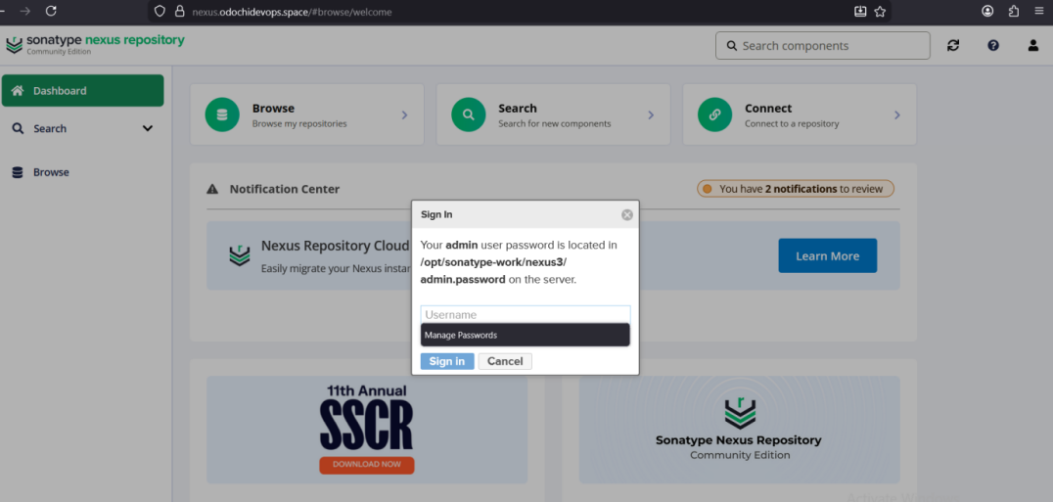

Next, go into the nexus server in AWS console and connect via ssm, run sudo cat (paste the path copied)

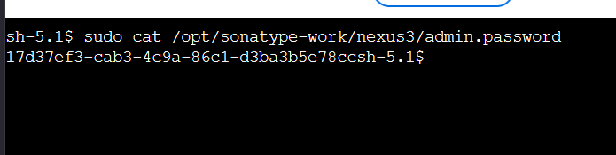

Go bact to the browser and paste the generated password and select next. This will take you to nexus repo manager, Follow the wizard until you click at Finish.
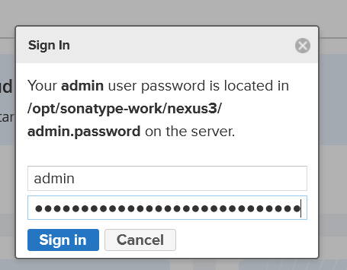

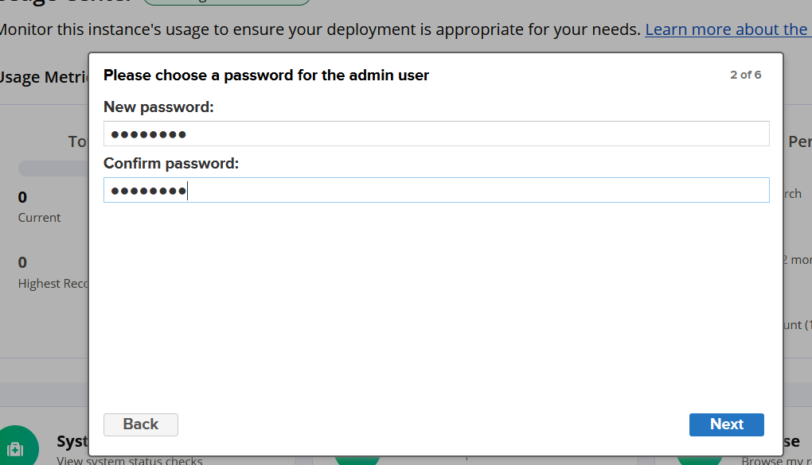

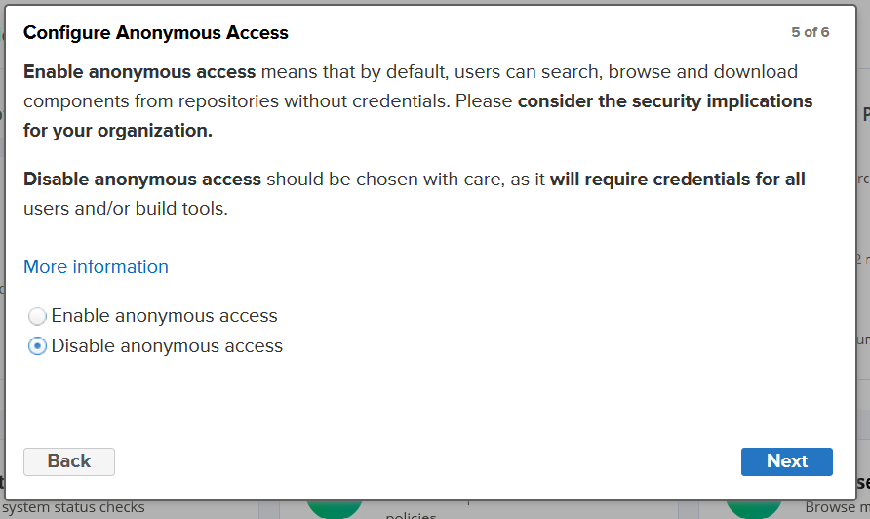

Next is to create the nexus-docker-repo. To do this go the left panel at the nexus dashboard. Select settings, then select repository

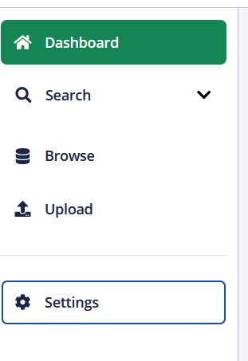
Next is the click create repository.
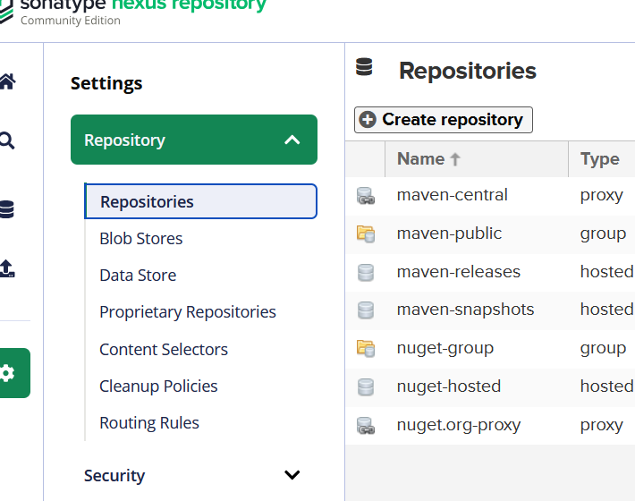

At the drop down list, select docker (hosted), then give the repository a name. Select the required items and click create.
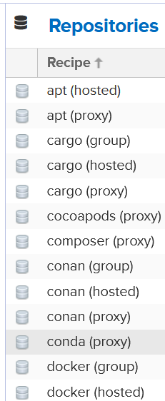

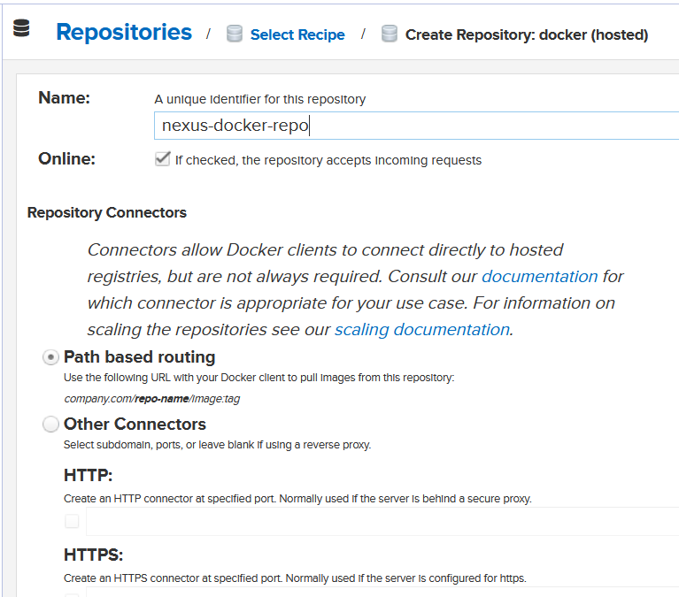

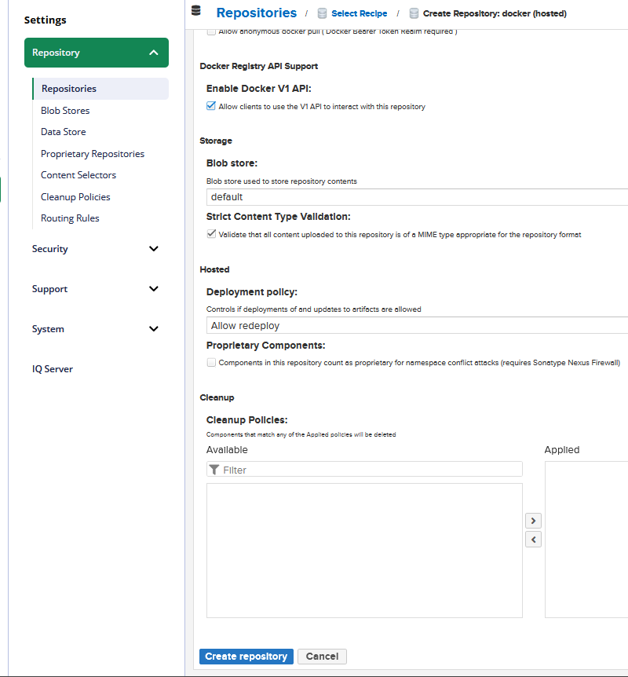

Go back to the nexus dashboard, under security, select Realms, then select enable docker Bearer tokens Realm, the click save.

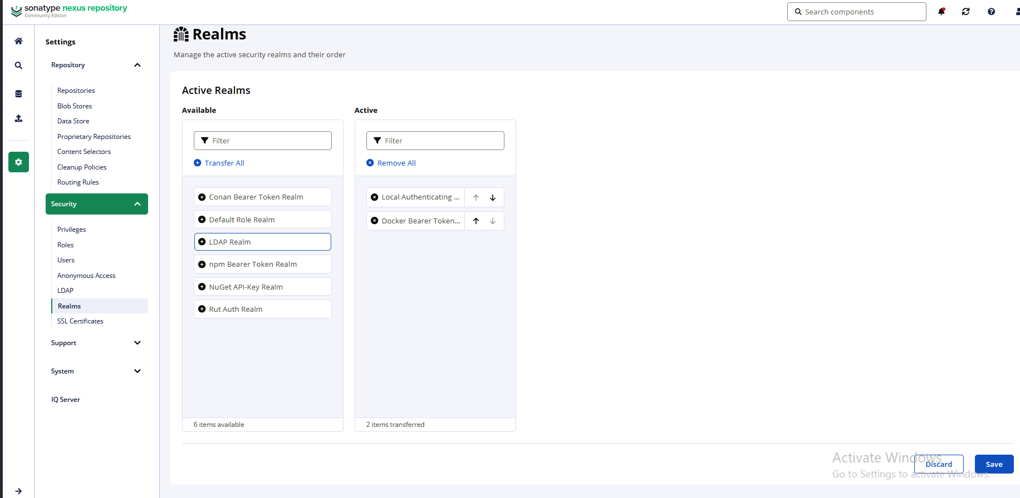

Next is to create maven repo. To do this, select create repository. Select maven2(hosted) ( make sure it matches the name on the jenkinsfile) then select the required items and ckic create repository.

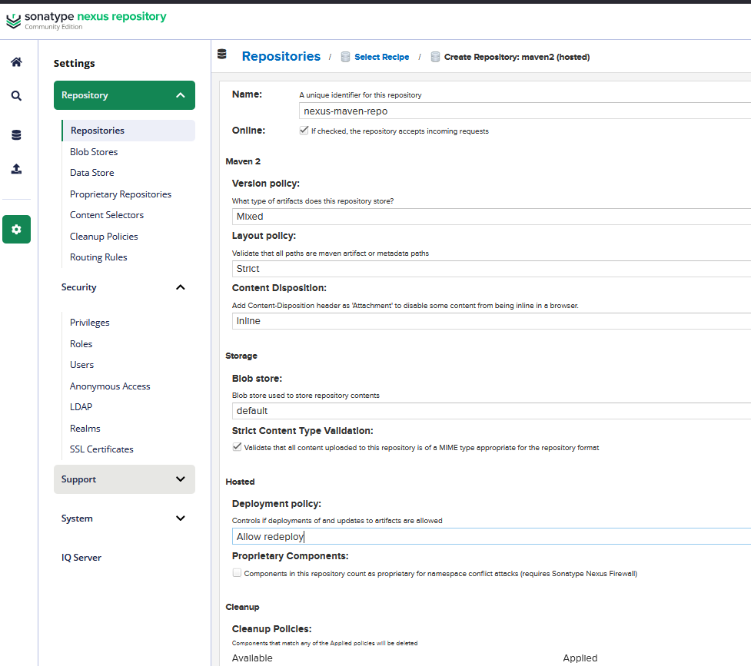

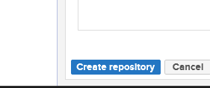

Recheck to make sure that the repositories are created.
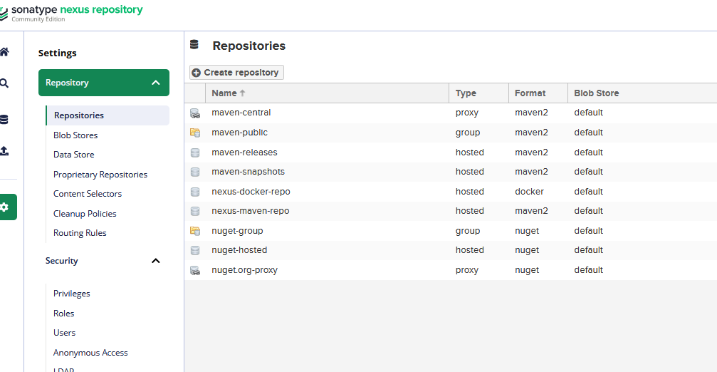

Have created all the required credentials and repositories. Next is to set up the pipeline. To do this got back to jenkins dashboard, Select New Item.
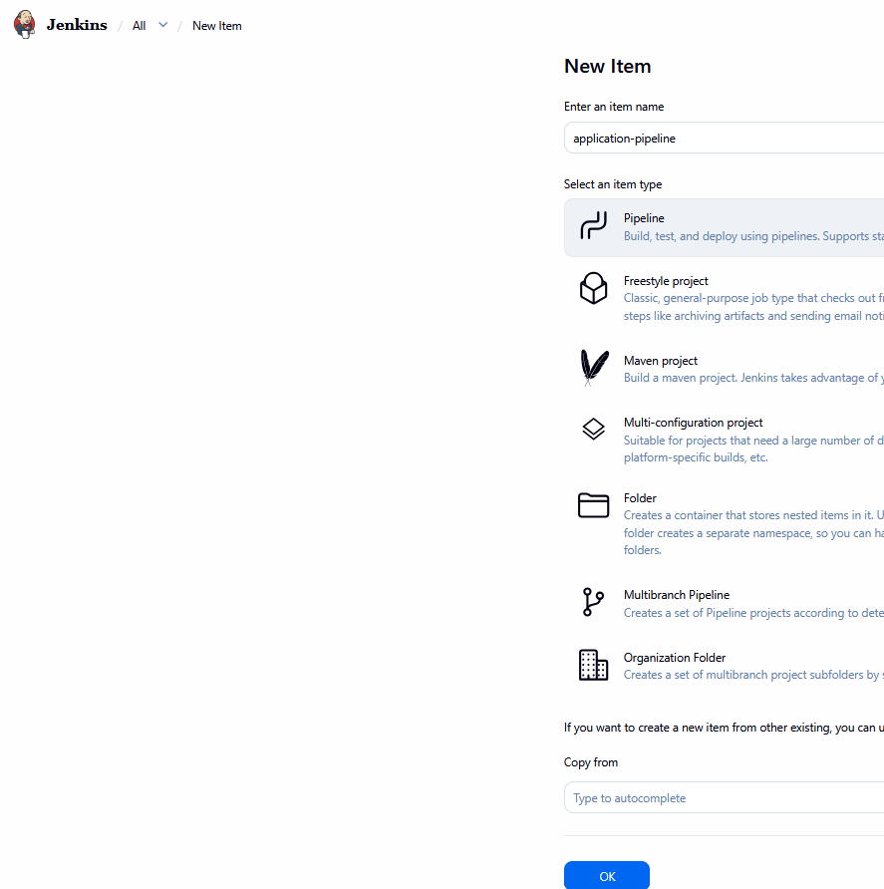

Deployment - automatic deployment to stage and production environments.

